MS Word
This is a Quarto document. To learn more about Quarto visit https://quarto.org.

Plots
See fig. 1 for an example of rendering plots as figures:
import numpy as np
import matplotlib.pyplot as plt
r = np.arange(0, 2, 0.01)
theta = 2 * np.pi * r
fig, ax = plt.subplots(subplot_kw={'projection': 'polar'})
ax.plot(theta, r)
ax.set_rticks([0.5, 1, 1.5, 2])
ax.grid(True)
plt.show()
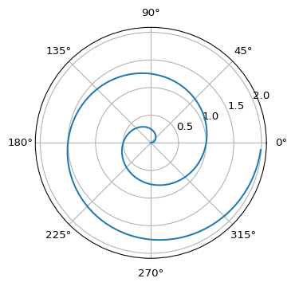
Figure 1: A line plot on a polar axis

